**MAKERERE  UNIVERSITY**

**MATERNAL MORTALITY RATE PREDICTION AND ADVISORY SYSTEM**

By

BSE21-11

DATA SCIENCE, EMBEDDED SYSTEMS

DEPARTMENT OF NETWORKS

SCHOOL OF COMPUTING AND INFORMATICS TECHNOLOGY

A Project Report Submitted to the School of Computing and Informatics Technology

for the Study Leading to a Project in Partial Fulfillment of the

Requirements for the Award of the Degree of Bachelor of

Science in Software Engineering of Makerere University.

Supervisor

Dr. Moses Ntanda

Department of Networks

School of Computing and Informatics Technology, Makerere University

Supervisor email, +256-41-540628, Fax: +256-41-540620

December, 2021

# Declaration

We, group BSE 21-11, hereby declare that the work presented is original and has never been submitted for an award to any university or institution of higher learning

|  |  |  |  |
| --- | --- | --- | --- |
| # | Names | Registration Number | Student Number |
|  | Wamala Edgar Watson | 17/U/20633/EVE | 217022321 |
|  | Kyanzi Hassan Musisi | 17/U/19979/EVE | 217022320 |
|  | Asiimwe Brenda Angel | 17/U/3014/EVE | 217002455 |
|  | Tindyebwa Fortunate Allan | 17/U/10441/EVE | 217005376 |

# Approval

This project report titled Maternal Mortality Rate Prediction and Advisory system has been submitted for examination with my approval as the supervisor of group BSE21-11.

Dr. Moses Ntanda

Networks Department

School of Computing and Informatics Technology;

College of Computing and Information Sciences,

Makerere University

Signature: ................................................... Date: ............................

Supervisor

# Dedication

We dedicate this project to our parents, guardians and siblings for all their financial and moral support they’ve rendered to us during our tenure as students of Bachelors of science in Software Engineering.

# Acknowledgements

This project called “Maternal Mortality Rate Prediction and Advisory System” is part of the Bachelors of Science in Software engineering four years’ curriculum. We have tried our level best to present this information as clearly as we could so, we hope it will be understood by the widest spectrum of system developers, data analysts, data scientists and students who would use it for further research.

We have completed this project under supervision and guidance of Dr. Moses Ntanda. We would like to acknowledge his enthusiasm, knowledge, time, attention to detail and insightful comments he has always given us. All this combined has pushed us and helped keep us on track .

# Abstract

Contents

1 Declaration ii

2 Approval iii

3 Dedication iv

4 Acknowledgements v

5 Abstract vi

1 Softwar1e Design Document 1

1.1 Scope 1

1.2 Overview 2

1.3 Reference material 2

1.4 System Overview 2

1.5 SYSTEM ARCHITECTURE 3

1.5.1 Architectural Design 3

1.6 Decomposition Description 5

1.6.1 Analysis and prediction subsystem 5

1.7 Advisory subsystem 7

1.7.1 Design Rationale 8

1.8 DATA DESIGN 8

1.8.1 Data Description 8

1.9 COMPONENT DESIGN 9

1.9.1 HUMAN INTERFACE DESIGN 9

2 Conclusion and Recommendations 11

2.1 Conclusion 11

2.2 Recommendations 11

3 Introduction 3

3.1 Background and scope of the project 3

4 Overview of the document 3

5 System Specifications 4

5.1 Version of requirements and Version Control 4

5.2 Inputs 4

5.3 Outputs 5

5.4 Functionality 5

5.5 Safety Requirements 6

5.6 Security Requirements 6

5.7 Limitations and safety 6

5.8 Default settings 7

5.9 Special requirements 7

5.10 Errors and alarms 7

6 Design output 8

6.1 Implementation (coding and compilation) 8

7 Documentation 9

8 Inspection and testing 10

8.1 Introduction 10

8.2 Test plan and performance 13

8.2.1 Test objectives 13

8.2.2 Scope and Relevancy of tests 13

8.2.3 Levels of tests 14

8.2.4 Installation and system acceptance test 14

**8.2.5** Supplementary files 15

8.3 Installation qualification 16

8.4 Performance, servicing, maintenance, and phase out 18

8.4.1 Service and maintenance 18

8.4.2 Future updates 18

8.4.3 Requested modifications 19

8.5 Performance and Maintenance 19

# Software Design Document

## Scope

The “MATERNAL MORTALITY RATE PREDICTION AND ADVISORY SYSTEM” is a mobile and web and application which helps to sensitize and advise the public about maternal health specifically pregnant women to attend antenatal care and also provide answers to the complications they are facing while pregnant. We shall issue advice through SMS messaging via an ‘SMS’ messaging system. This system also does analysis and prediction of maternal mortality in the coming years or months.

The system administrators shall obtain details of pregnant women from information gathered at different health facilities for the start as we find other means to capture data about those mothers that visit the hospital while they’re about to give birth or never visit at all. The system will pick the already existing information from the database which include phone numbers of mothers on which messages will be sent. The pregnant mothers on the other hand can send in their issues to an assigned phone number to get a reply with a very short time. An administrator also uses the web-portal to manage the system and keep the information accurate. The administrator can, for instance verify user details, approve system officials on web-portal and manage user information.

Furthermore, the software needs both Internet to send requests to database and receive response from database through webserver. All system information is maintained in a database, which is accessed through a webserver. The web portal will be mainly used by the system administrator, and it has the capability of analytically representing both summary and detailed information about the results for the maternal mortality analytics, through the web portal too the administrators will verify users, track user results, register other administrators, among others as further explained in the system architecture.

## Overview

The Software Design Document is divided into 7 sections with various subsections. The sections of the Software Design Document are:

1. Introduction
2. System overview
3. System architecture
4. Data design
5. Component design
6. Interface design
7. Requirement matrix

## Reference material

We have an appendix of reference for this project.

## System Overview

This Maternal Mortality Prediction and Advisory System comprises three modules: a prediction system, a web portal, and an SMS messaging system. The sms messaging system comes to a mobile phone through GSM technology, which aids the sending of messages to the pregnant women phones.

This is a data-based application, it requires a data store, and thus a database is needed. The web portal communicates with the database via a web server, however in slightly different ways. The web portal is mainly be used by users to add and modify data. problems with overloading the operating system the application is only allowed to use 20 megabytes of memory while running the application. The maximum amount of hard drive space is also 20 megabytes.

## SYSTEM ARCHITECTURE

### Architectural Design

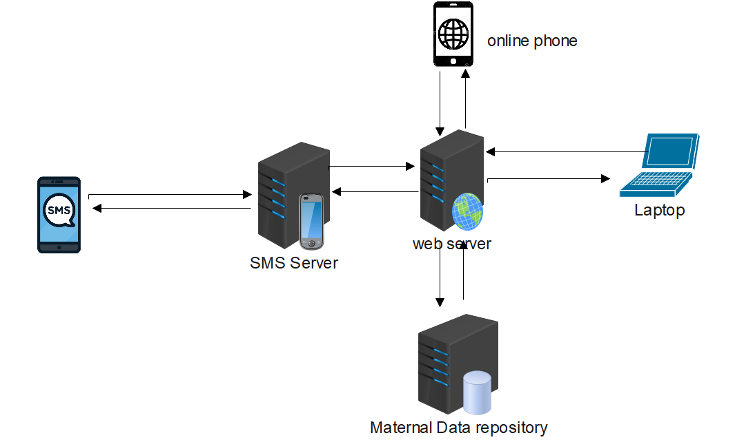

Figure 1:Architecture Design

Repository architecture

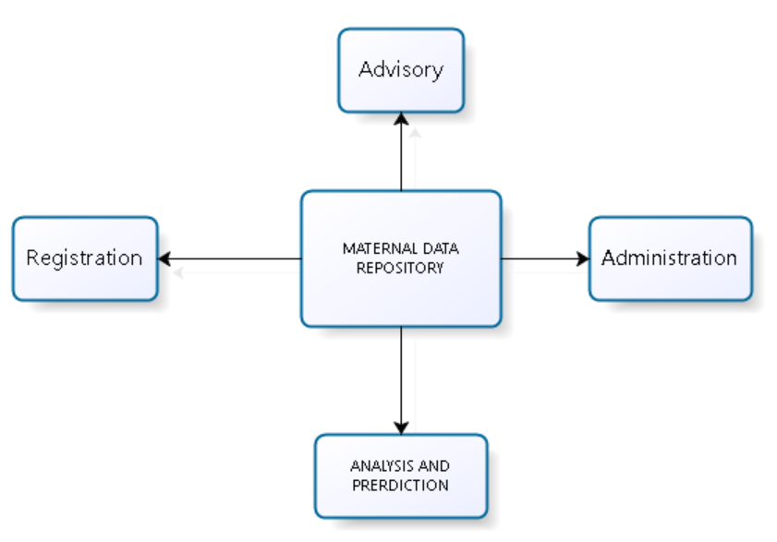

Figure 2:Repository Architecture

**Analysis and prediction model.**

Uses data from the data repository to make analysis and prediction.

**Administration model.**

The admin model uploads new dataset to a repository and also manages user accounts.

**Advisory model.**

The advisory subsystem uses data from the repository to offer advice to the pregnant mothers and health workers like the doctors.

## Decomposition Description

### Analysis and prediction subsystem

Data cleaning

In this step, you’ll need to transform the data into a **clean** format so that the machine learning algorithm can learn useful information from it. Data, in general, is messy, so expect to discover different issues such as missing, outliers, and inconsistency. This step will often take a long time as well.

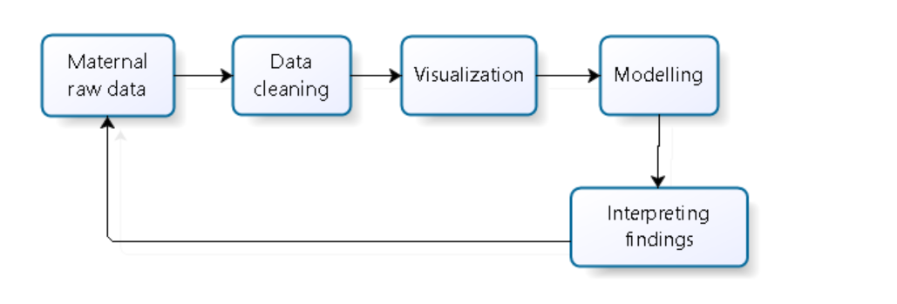

Figure 3:Data pipeline

**Data visualization**

Data visualization is **the graphical representation of information and data**. By using visual elements like charts, graphs, and maps, data visualization tools provide an accessible way to see and understand trends, outliers, and patterns in data.

**Data modelling**

Data modelling in software engineering is the process of creating a data model for an information system by applying certain formal techniques.

**Interpreting findings**

Interpreting findings is about seeing whether **what you found confirms** or does not confirm the findings of previous studies in your literature review. Your findings may also offer novel insights or information.

## Advisory subsystem

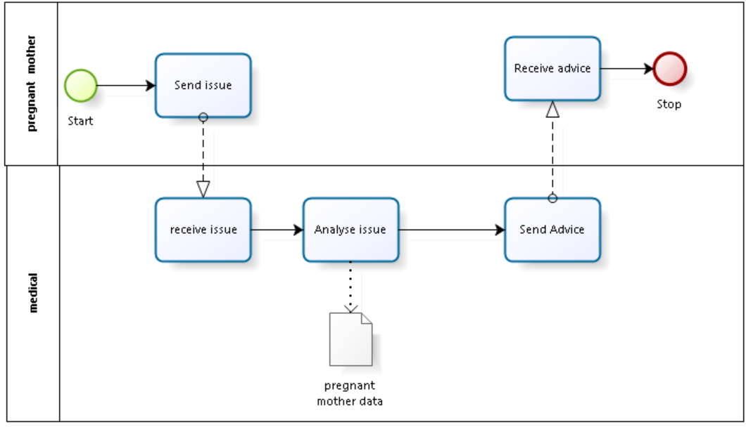Figure 4:Advisory sub system

**Send issue.** The process starts by a pregnant mother sending a problem or an issue.

**Receive issue**. The medical system receives the issue

**Analyze issue**. The system analyses the issue basing on the data stored in the repository and sends advice to the pregnant mother

Then, finally the pregnant mother will receive advice either SMS or mobile and email

**Lanes**

* Medical
* Pregnant mother

**Activities**

* Send issue
* Receive issue
* Analyse issue
* Send advice
* Receive advice

Data

* Pregnant mother data

### Design Rationale

All data in a system is managed in a central repository that is accessible to all system components. Components do not interact directly, only through the repository.

We decided to use this architecture because; Components can be independent--they do not need to know of the existence of other components. Changes made by one component can be propagated to all components. All data can be managed consistently (e.g., backups done at the same time) as it is all in one place.

**With Client-server architecture**, each service is a single point of failure so susceptible to denial-of-service attacks or server failure. Performance may be unpredictable because it depends on the network as well as the system. May be management problems if servers are owned by different organizations.

**With Pipe and filter architecture**, the format for data transfer has to be agreed upon between communicating transformations. Each transformation must parse its input and unparsed its output to the agreed form. This increases system overhead and may mean that it is impossible to reuse functional transformations.

## DATA DESIGN

### Data Description

Table 1:Data Dictionary

|  |  |  |  |  |
| --- | --- | --- | --- | --- |
| **Table Name** | **Attribute name** | **Type** | **Size** |  |
| Maternal Registration | Name | Varchar | 30 |  |
| Location | Varchar | 30 |  |
| Pregnant status | Varchar | 40 |  |
| Hospital | Varchar | 30 |  |
| Age | Number | 10 |  |
| Contact | Varchar | 20 |  |
| Advisory table | Problem | Varchar | 100 |  |
| Solution | Varchar | 100 |  |
| New problem | Varchar | 100 |  |
| Approved | Boolean | 6 |  |
| Date | Date | 8 |  |
| Users | Name | Varchar | 30 |  |
| location | Varchar | 30 |  |
| Title | Varchar | 30 |  |
| contact | Varchar | 30 |  |
| Hospital | Varchar | 30 |  |
| Password | Password | 30 |  |

## COMPONENT DESIGN

### HUMAN INTERFACE DESIGN

Admin interface

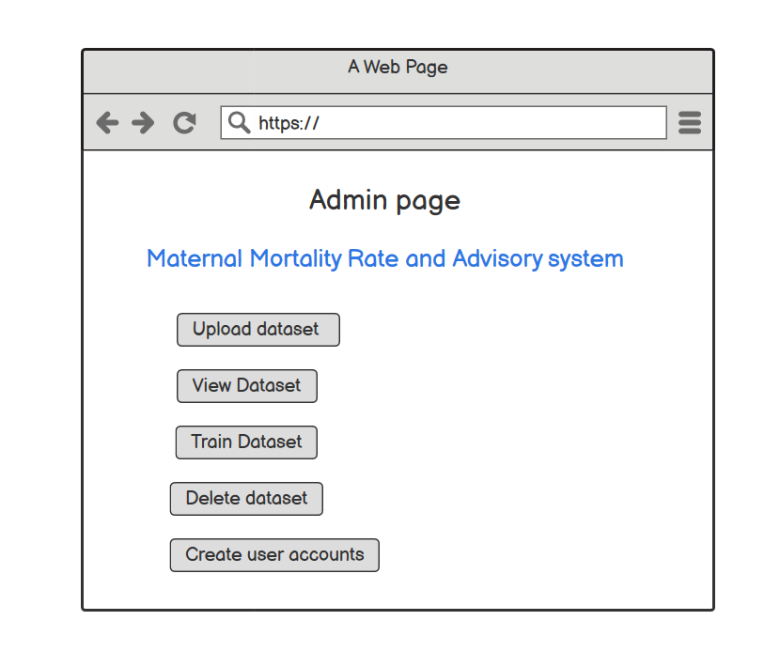Figure 5:Admin Interface

Doctor’s interface

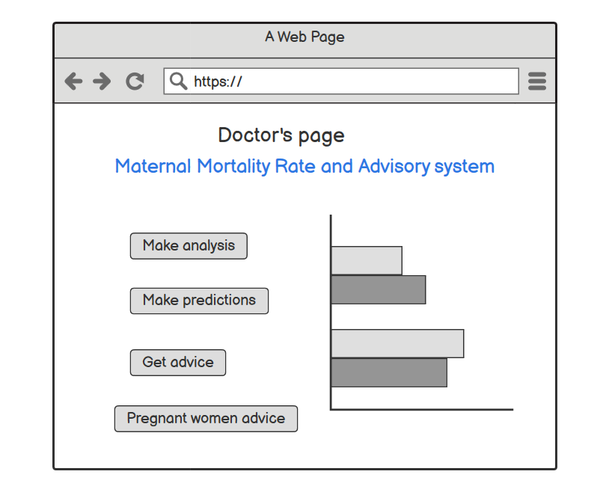Figure 6:Doctor's Interface

The System owners and Administrators shall interact with the system through a web-portal where the System owner should be able to register with Username and password on the web-portal to log in and manage the system information and an administrator also can be able to log in to the web-portal with a username and password where he/she can administer the system by for instance editing system or user information.

The dataset will be uploaded to the server through a web browser application.

The communication between the database, client application side and the web-portal consist of operation concerning reading and modifying data, while the communication between the application and database will be through reading only.

The communication between the phone and the server will through an SMS api that shall be uploaded on the server.

# Conclusion and Recommendations

## Conclusion

The MMRPA system was fully tested using various testing techniques and methods such as reviewing documentations such as SRS, SDD of the MMRPA system. The defects identified through unit testing and integration testing were documented and fixed to satisfy the user needs.

## Recommendations

It should be noted that the accuracy of the prediction results depends on the accuracy of the model. We therefore recommend that more data should be trained to produce more accurate data.

The prediction result provided by MMRPAS system is not a confirmatory test. We found out that out of 100 pieces of advice, the system can accurately provide 96 users with accurate advice. We recommend mothers to visit the next medical Centre in case of serious advice.

**System implementation, testing and validation report for maternal mortality rate prediction and advisory system.**

|  |  |
| --- | --- |
| Document No: |  |
| Prepared by: | KYANZI HASSAN MUSISI  WAMALA EDGAR WATSON  ASIIMWE BRENDA ANGEL  and TINDYEBWA ALLAN FORTUNATE |
| Date: | 20th-01-2022 |
| Version: | 3.0 |

Document Approval

|  |  |  |  |
| --- | --- | --- | --- |
| **Name** | **Role** | **Date** | **Signature** |
| Asiimwe Brenda Angel | Author |  |  |
| Tindyebwa Fortunate Allan | Author |  |  |
| Wamala Edgar Watson | Author |  |  |
| Kyanzi Hassan Musisi | Author |  |  |
| Dr. Moses Ntanda | Validation |  |  |
|  | Client |  |  |

# Introduction

## Background and scope of the project

Despite efforts made by the Ugandan government to improve maternal and neonatal health care service delivery, The causes of Maternal mortality over the last decade are flagrantly the same. Maternal Mortality in Uganda is about 343 per 100,000 live births.

Maternal Mortality is death of women during pregnancy or child birth. Uganda wants to achieve the Sustainable Development Goals (SDGS) in particular goal 3 which is to reduce the Global maternity ratio to less than 70 per 100,000 live births and that’s the reason it is tooth and nail to reduce maternal mortality and this can be implemented using evidence-based means of MPDSR interventions throughout all levels of the health care system.

Maternal and Perinatal Death Surveillance and Response (MPDSR) is defined as a critical approach for improving quality of care for maternal and neonatal health. MPDSR is also instrumental to inform advocacy, policy, planning, service delivery and accountability towards ending preventable maternal and neonatal mortality. The practice of MPDSR facilitates targeted implementation of evidence-based interventions to address the underlying causes of maternal death. It, therefore, becomes an important strategy for attaining SDGs.

Many international health bodies agree that in order to combat maternal mortality, data collected must be accurate to ensure preventable maternal deaths are reduced. So, there has been so many efforts to collect and utilize maternal mortality data however, the challenge is failure to utilize this data fully to develop and implement recommendations and action points.

MMRPAS (Maternal Mortality Rate Prediction and Advisory System) relies on the data collected in DHIS2 system about Maternal Mortality to make prediction then derive advice to mothers recorded in our database.

# Overview of the document

This document describes the implementation, testing and validation findings for the MMRPA system. It is divided into the following sections;

Section 4: This section gives an overview of the document

Section 5: Give information about system specifications

Section 6: This is about system Inputs

Section 7: This is about system Outputs

Section 8: This shows Functionality of the system.

Section 9: Design Outputs

# System Specifications

The section describes and specifies the system completely and is the basis for the validation process.

## Version of requirements and Version Control

Version 1.1 of the requirements specification was derived from Version 1.0(initial version) by an advisory module to the system. This change was made becausee it was relevant for our system to not only predict but also advise those seeking information about maternal health. This was added to version 1.1 of the MMRPA system.

We used GIT as our version control tool and git tags were used to distinguish between one version and another.

## Inputs

All inputs the MMRPA system are past values of the pes concatenated with other driving time series values and timestamp embeddings. If past deaths per region will be used to utilize them to condition the prediction too.

**Input 1: The maternal mortality data**

This data is downloaded from DHIS2 System, a ministry of health system.

**Input 2: Time Range for data visualization**

This is an input to the visualization feature which specifies the graphs to be displayed based on the date range input.

**Input 3: Message**

This is an input to the notification feature. it describes the content of the message that will be sent to the the mother seeking advice.

**Input 4: Date of Reminder**

This is an input to the notification feature which sets the date of sending a notification to the mother entailing the next antennal care date. The date set, must be from the present date and onwards.

**Input 5: Advisory data**

Consequently, providing advice to different users involves the system calling to a machine learning model which will then identify the data related to what the user requires. The result is then sent to the display the advice to the user.

## Outputs

**Output1: Prediction results**

This is an output of the prediction feature. It is generated by the predictions subsystem and sent to the MMRPAS by the help of an API. Prediction results include Maternal mortality rates and prediction is expressed as numbers.

**Output2: Graphs**

This is an output of the visualization feature, and it consists of the Bar graphs and Pie charts and other graphs that show the maternal mortality in a given region based on the time range set.

**Output 3: Reminder**

This is an output of the notification feature that notifies mothers about their next Antenatal care. This is sent periodically based on the set date in the database and their content is dynamically set by the doctor.

## Functionality

**R001** MMRPA system shall allow health officials to predict maternal mortality.

The user shall input a data range which will be sent to the prediction subsystem by the API. The prediction results will be sent back to the MMRPA subsystem. The user shall be able to view the prediction results and then save them into the database.

**R002** MMRPA system shall provide graphical analysis of the prevalence of maternal mortality in different regions.

The user shall input the time range to view the rate maternal mortality within the set time range and this data will be displayed in graphical form using Bar Charts and Pie Charts and other graphs.

**R003** MMRPA system shall notify mothers registered about the next antennal care visit.

**R004** MMRPA system shall provide reply to issues sent by pregnant mothers.

## Safety Requirements

The System will provide a warning message for mothers to seek for further assistance.

## Security Requirements

1. The MMRPA system will ensure data integrity whereby user data and records will be protected from unauthorized modification of the data.
2. The MMRPA system will be protected from DDOS attacks to increase availability of the system to the right system users.
3. Data transferred between the device accessing the MMRPA and the cloud will be encrypted to ensure data confidentiality.

## Limitations and safety

1. The level of accuracy of the results for advisory part is affected by a machine learning model which requires enough training to produce nearly accurate results.
2. The accuracy of the prediction depends on the model developed.
3. Since the system is to be accessed online, the users won't be able to perform predictions and send notifications in case they are not connected to the internet.

## Default settings

By default, the mother has to be notified on the same day she is supposed to come for an antenatal care visit. However, this can be adjusted by the doctor based on the pregnant woman’s preference.

## Special requirements

1. The admin’s credentials such as the password were encrypted preventing anyone having access to the database such as the database administrator to view the doctor's password.
2. Access to maternal health data is limited to only the super administrators who worked on that particular patient.

## Errors and alarms

1. In case the API to the prediction subsystem is offline, a message is shown during prediction.
2. In case the date format is violated an error message is shown.
3. In case the connection to the database fails, an error message indicating Database Failure is displayed.

# Design output

## Implementation (coding and compilation)

1. **Anaconda:** This is an environment we used to create, train, and test the maternal mortality model. This platform offers high computing resources which are required during the training phase of the model.
2. **Visual studio code:** This was our main text editor in the development of the system.
3. **GitHub:** This version control system enabled us to keep track of our code and documents during the development.
4. **MySQL server:** This enabled us in creating and managing our database.
5. **Postman:** This was used in the testing of the API that connects to the prediction backend model.
6. **Django framework:** This was used in achieving a better well-organized code that is modular and easy to maintain.
7. **Balsamiq:** We used this tool to design the user interface of the MMRPA system.
8. **Microsoft Visio:** This tool was used for drawings such as context diagrams, use case diagrams, entity relationship diagrams.
9. **Web Browser:** Google Chrome and Mozilla Firefox were used to run and test the MMRPA system.
10. **Stationary:** Pens, ruler and Paper were used to come up with low fidelity user interfaces for MMRPA.

|  |
| --- |
| Documentation |
|  |

| *Topics* | **Design output** | |
| --- | --- | --- |
| **Good programming practice**  *Efforts made to meet the recommendations for good programming practice...* | Source code is... | Source code contains... |
| **Windows programming**  *If implementing Windows applications... remove this row* | Comments: | |
| **Dynamic testing**  *Step-by-step testing made dynamically during the implementation...* | Comments: | |

Table 3:Design Details

# Inspection and testing

## Introduction

Inspection and testing of the Maternal Mortality Rate Prediction and Advisory System involved preparation and thorough checking of the different MMRPAS project documents such as the SRS and SDD. This was done by the project members as the reviewers.

The group members of the MMRPAS project went ahead to examine the MMRPAS application by executing the application and defects found, were documented in an issue log which were later fixed.

Table 4: Inspection plan and performance:

|  |  |  |  |  |  |  |  |  |
| --- | --- | --- | --- | --- | --- | --- | --- | --- |
|  | **Topics** |  |  | **3.3.1 Inspection plan and performance** |  |  | **Date / Initials** |  |
|  |  |  |  |  |  |
|  |  |  |  |  |  |  |  |  |
| **Design output** | | |  | Program coding structure and source code | | 14/12/2021 | |  |
|  |  |  |  | Evidence of good programming practice | |  | Performed By | |
|  |  |  |  |  |  |  |
|  |  |  |  | Design verification and documented reviews | |  | Wamala Edgar Watson | |
|  |  |  |  |  |  |  |
|  |  |  |  | Change-control reviews and reports | |  |  |  |
|  |  |  |  | **Comments:** | |  |  |  |
|  |  |  |  | We reviewed the code structure, the software | |  |  |  |
|  |  |  |  | Design documents, and the system | |  |  |  |
|  |  |  |  | requirements specification. | |  |  |  |
|  |  |  |  | Both code and documents were well organized | |  |  |  |
|  |  |  |  | and well formatted. | |  |  |  |
|  | | |  |  | |  | |  |
| **Documentation** | | |  | System documentation, flow charts, etc. | | 14/12/2021 | |  |
|  |  |  |  | Test results | |  | Performed by | |
|  |  |  |  |  |  |  |
|  |  |  |  | User manuals, On-line help, Notes, etc. | |  | Asiimwe Brenda Angel and Tindyebwa Fortunate Allan | |
|  |  |  |  |  |  |  |
|  |  |  |  | Contents of user manuals approved | |  |  | |
|  |  |  |  |  |  |  |  | |
|  |  |  |  | |  |  |  |  |
|  |  |  | 10 | |  |  |  |  |



|  |  |  |  |  |  |  |  |  |
| --- | --- | --- | --- | --- | --- | --- | --- | --- |
|  | **Topics** |  |  | **3.3.1 Inspection plan and performance** |  |  | **Date / Initials** |  |
|  |  |  |  |  |  |
|  |  |  |  |  |  |  |  |  |
| **Software development** | | |  | Data integrity | | 14/12/2021 | |  |
| **environment** | | |  | File storage | |  |  |  |
|  |  |  |  |  | Performed by | |
|  |  |  |  |  |  |  |
|  |  |  |  | Access rights | |  | Kyanzi Hassan Musisi | |
|  |  |  |  |  |  |  |
|  |  |  |  | Code protection | |  |  |  |
|  |  |  |  | Installation kit, replication and distribution | |  |  |  |
|  | | |  |  | |  | |  |
| **Result of inspection** | | |  | Inspection approved | | 20/01/2022 | |  |
|  |  |  |  |  |  |  | The inspection | |
|  |  |  |  |  |  |  | was approved by | |
|  |  |  |  |  |  |  | all the team | |
|  |  |  |  |  |  |  | members. | |
|  |  |  |  |  |  |  |  |  |



## Test plan and performance

### Test objectives

1. To confirm that the system works as expected by the end-user. This test was performed together with a team of health officials at the Ministry of Health.
2. To find out whether the Prediction model is able to predict maternal mortality.
3. To find out whether advice sent to users is accurate to a given percentage.
4. To find out whether the prediction data can be visualized in graphs basing on regions and time range. This was done by setting the time range and the MMRPAS system was able to display the graphs based on the set time range.
5. To find out whether all the requirements that were stated in the SRS were fully implemented. This was done by reviewing the SRS document to identify core requirements of the MMRPAS system which were later compared to the main functions the MMRPAS system provides to the end user.
6. To find out whether the system features i.e. Prediction feature, visualization feature, and Notification feature work together after integration. This was done by testing these features separately, and then we tested the system as a whole after integration.

### Scope and Relevancy of tests

1. Data that was used for testing the Prediction feature were different from the ones used for Training the Prediction feature.
2. The advice can only be dependable in case the level of accuracy is above 80%. Once the level of accuracy is below 80%, further tests or reviews are highly recommended.

### Levels of tests

**Module Test**

Modules that were tested included the Prediction module, the Notification module, Advisory module and the Visualization module.

**Under the Prediction module**, some random samples of the mmaternal mortality data were obtained online with defined results were tested with the MMRPAS prediction model and 90% of the prediction results were able to match the defined results of the online mammogram images.

We found out that the accuracy of the prediction depends on how trained the prediction model has been trained.

### Installation and system acceptance test

#### Input files

The following files will be required in order to deploy both the Maternal Mortality Rate Prediction and Advisory client Application and the MMRPAS Model online.

1. **MMRPAS Client.zip**

This Zipped folder contains files for handling the client logic such as sending the request predict to the model, Visualization of maternal mortality and notifying mother about the next antenatal care visit.

1. **MMRPAS Backend.zip**

This Zipped file contains the backend logic which receives the request from the client through the API, performs the prediction process, and sends back the prediction results and advice to the client App or message.

**MMRPAS.h5**

This is a saved trained model which is used to predict the presence of breast cancer.

### Supplementary files

1. Readme file

The readme file includes the operation instructions, file manifest, contact information for the programmers, known bugs, link to MMRPAS’s github repository,and the link to the project blog.

1. User manual

The user manual includes instructions about how to use the MMRPAS system.

## Installation qualification

The following Steps ensure and document that each component is deployed correctly.

Table 5:Checklist of the Installation and system acceptance test

|  |  |  |  |  |  |  |
| --- | --- | --- | --- | --- | --- | --- |
|  | *Topics* |  |  | **Installation summary** | |  |
|  |  |  |  |
|  |  |  |  |  | |  |
| **Installation method** | | |  | Automatic - installation kit located on the installation media | | |
|  |  |  |  | Manual - Copy & Paste from the installation media | | |
|  |  |  |  | **Comments:** | | |
|  |  |  |  | Deployment is done by just unzipping the **MMRPAS Client.zip and** | | |
|  |  |  |  | **MMRPAS Back.zip**, and uploading **MMRPAS.h5** | | |
|  | | |  |  | | |
| **Installation media** | | |  | Diskette(s) | | |
|  |  |  |  | CD-ROM | | |
|  |  |  |  | Source disk folder (PC or network) | | |
|  |  |  |  | Download from the Internet | | |
|  |  |  |  | **Comments:** | | |
|  |  |  |  | All the files to be deployed are included in the folder. | | |
|  | | |  | |  | |
| **Installed files** | | | 1. | | PHP files | |
|  |  |  | 2. | | Blade files | |
|  |  |  | 3. | | Python files | |
|  |  |  | 4. | | Keras h5 file | |
|  |  |  |  |  |  |  |



Table 6.1 : Installation Procedure Check

|  |  |  |  |  |  |  |  |  |
| --- | --- | --- | --- | --- | --- | --- | --- | --- |
|  | **Topics** |  |  | **Installation procedure** |  |  | **Date / Initials** |  |
|  |  |  |  |  |  |
|  |  |  |  |  |  |  |  |  |
| **Authorization** | | |  | Person responsible: | | 14/12/2021 | |  |
|  |  |  |  | KYANZI HASSAN MUSISI | |  |  |  |
|  | | |  |  | |  | |  |
| **Installation test** | | |  | Tested and approved in a test environment | | 15/12/2021 | |  |
|  |  |  |  | Tested and approved in actual environment | |  |  |  |
|  |  |  |  | Completely tested according to test plan | |  |  |  |
|  |  |  |  | Partly tested (known extent of update) | |  |  |  |
|  |  |  |  | **Comments:** | |  |  |  |
|  |  |  |  | The installations were completely tested and | |  |  |  |
|  |  |  |  | approved in both test and actual environments | |  |  |  |
|  |  |  |  | according to the test plan. | |  |  |  |
|  |  |  |  |  |  |  |  |  |



## Performance, servicing, maintenance, and phase out

### Service and maintenance

**Service and support concerning maintenance**

The programmers of the MMRPA system shall provide the following Maintenance and Support Services.

1. Programmers shall assess all changes to the MMRPAS and ensure that the changes made are tested.
2. Programmers shall provide Support Services via the Call Centre, E-mail Support and Web-based Support.
3. Programmers shall periodically deploy releases of the MMRPAS online.
4. Programmers shall monitor the operation of the MMRPAS and identify potential issues.
5. Programmers shall apply continuous efforts and resources to resolve any defect identified in the MMRPAS system.

### Future updates

1. Except in cases of emergency, Programmers shall notify the end users at least two days prior to activating each Update.
2. Version Control such as git shall be used to track and audit modifications to the MMRPAS components over time, and to facilitate the restoration of MMRPAS to prior development stages.

### Requested modifications

1. End users requesting for system modifications shall be required to fill and submit the change request form.
2. The requested change shall be analysed by the programmers of MMRPAS
3. Impact analysis shall be performed. The programmers shall assess the impact of the requested change to the MMRPAS system.
4. The programmers will decide to approve, reject, or put the requested change on hold.
5. If the requested change is approved, the programmers shall implement the change and update the system.

## Performance and Maintenance

The maximum time required for advice in form of sms reply is 5 seconds.

The accuracy of the trained prediction model of the MMRPAS system will be improved through continuous training of the MMRPAS model with more new maternal mortality obtained from a trusted source.

Online user manuals and hard copy manuals shall be provided to guide the intended users on how to use the MMRPAS system. Online user manuals will be immediately updated in case of a new feature or change to the MMRPAS system.

The MMRPAS system will be upgraded based on the changes requested or suggested by the intended users and the build versions will be managed using version control systems such as git.

Table 7: Performance and maintenance details

|  |  |  |  |  |  |  |  |  |
| --- | --- | --- | --- | --- | --- | --- | --- | --- |
|  | **Topics** |  |  | **Performance and maintenance** |  |  | **Date / Initials** |  |
|  |  |  |  |  |  |
|  |  |  |  |  |  |  |  |  |
| **Problem / solution** | | |  | We detected that when a user enters so many words in their message, iyts difficult for the system to return a proper reply. | | 01/1/2022 | |  |
|  |  |  |  |  | |  |  |  |
|  |  |  |  |  | |  |  |  |
|  |  |  |  |  | |  |  |  |
|  |  |  |  |  | |  |  |  |
|  | | |  |  | |  |  |  |
| **Functional maintenance** | | |  | In case of any change in the functionality of | |  |  |  |
|  |  |  |  | MMRPAS system, the registered users shall be | |  |  |  |
|  |  |  |  | notified 2 days before the upgrade. | |  |  |  |
|  | | |  |  | |  |  |  |
| **Functional expansion** | | |  | The following suggestions are critical for the | |  |  |  |
| **and performance** | | |  | better performance of MMRPAS system. | |  |  |  |
| **improvement** | | |  | 1. [*Caching*](https://www.dnsstuff.com/web-application-performance#caching) | |  |  |  |
|  |  |  |  | 2. Optimizing the mammogram images. | |  |  |  |
|  |  |  |  | 3. Using Logs to monitor the | |  |  |  |
|  |  |  |  | performance of the system. | |  |  |  |
|  |  |  |  |  |  |  |  |  |
|  |  |  |  |  |  |  |  |  |